**PUBLIC NOTICE**

**CITY OF DANA POINT**

NOTICE IS HEREBY GIVEN THAT a public hearing, via teleconference, will be held in accordance with Governor Newsom’s Executive Order N-25-20, by the Planning Commission of the City of Dana Point to consider the following:

**Local Coastal Program Amendment LCPA19-0003/Zone Text Amendment ZTA19-0003-Zoning Code Update:** The applicant, RD Olson Development, is requesting to amend the Dana Point Harbor Revitalization Plan and District Regulations (Harbor Plan) for Planning Area 3 (PA3) and the regulations associated with hotel development in the Orange County Dana Point Harbor.

**Project Number:** Local Coastal Program Amendment LCPA19-0003/Zone Text Amendment ZTA19-0003

**Project Location:** Orange County Dana Point Harbor

**Applicant:** RD Olson Development

**Environmental:** Exempt from CEQA pursuant to Section 15265(f)

**Hearing Date:** Wednesday, May 27th, 2020

**Hearing Time:** 6:00 p.m. (or as soon thereafter as possible)

**Hearing Location:** The public is invited to view this meeting via The City of Dana Point YouTube Channel

All persons either favoring or opposing this proposal are invited to present their views on the above referenced project to the Director during this teleconference public hearing. Participants are encouraged to submit their written comments prior to the teleconference to [snicholas@danapoint.org](mailto:snicholas@danapoint.org).

**Note:** If you challenge the action taken on this proposal in court, you may be limited to raising only those issues you or someone else raised at the public hearing described in this notice, or in written correspondence delivered to the City of Dana Point prior to the public hearing.

For further information, please call Sean Nicholas, Senior Planner at the City of Dana Point, Community Development Department, 33282 Golden Lantern, Suite 209, Dana Point, (949) 248‑3588, or by email at snicholas@danapoint.org.

STATE OF CALIFORNIA      )

COUNTY OF ORANGE    )            ss         AFFIDAVIT OF POSTING

CITY OF DANA POINT         )

I, Brenda Wisneski, Director of the Community Development Department of the City of Dana Point, do hereby certify that on or before May 15, 2020, I caused the above notice to be posted in four places in the City of Dana Point, to wit: City Hall, the Dana Point Post Office, and the Capistrano Beach Post Office.

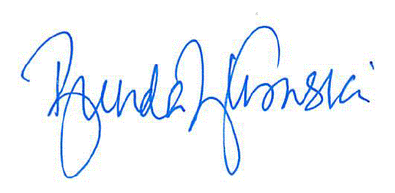

________________________________

Brenda Wisneski, Director

Community Development Department



# City of Dana Point

### Sean Nicholas – LCPA19-0003/ZTA19-0003

### Community Development Department

33282 Golden Lantern

Dana Point, CA 92629-1805



IMPORTANT PUBLIC HEARING NOTICE

**This May Affect Your Property**