Why is Operation Holiday Homework important to our Youth and Community?
For many of our members the gifts they receive from Operation Holiday Homework are the only gifts their family members receive during the holiday season.
Operation Holiday Homework encourages youth to take their education seriously.

Operation Holiday Homework

What is Operation Holiday Homework?
Operation Holiday Homework is a homework incentives program. Monday- Thursday from 2:30 to 3:30pm every member in the building participates in Power Hour (homework hour). At the end of the power hour time each member who did their homework and stayed on task receives two power hour points. Two weeks before Operation Holiday Homework the points for each member are tallied.

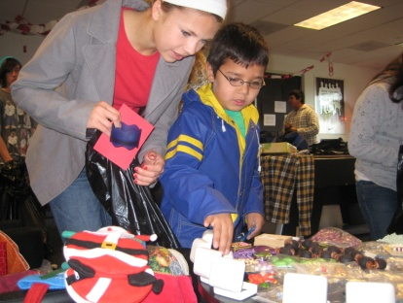
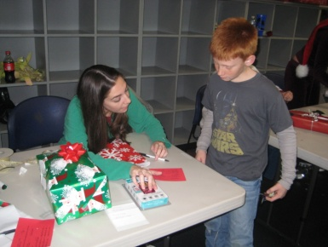

How do the points work?
The points only refer to the time frame in which the members come to the event. The members with the highest points get to come in first and get to pick the best items for their family members. A month before the event, staff will meet with each member to fill out a 3 x 5 card listing all the members of the youth’s family who live in their immediate household. The 3x 5cards come in handy for the shoppers.

How you can get involved!!!

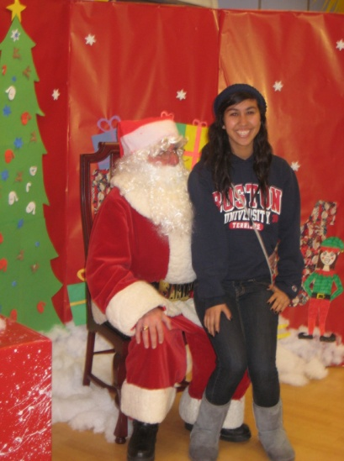
Collect new unwrapped gifts.
The Club staff will supply your company with a box to collect new unwrapped gifts. By collecting gifts your company makes the event possible. Gifts are broken down into these following categories: boys, girls, mother, father, babies, and teens. We need around 1,000 toy pieces, 500 female gifts and 500 male gifts.
Gift types include but are not limited to: Lego’s, board games, Barbie’s, remote control cars, gift cards, lotions, nail polish, tools, sports equipment, etc.

How you can help the day of the event.
Operation Holiday Homework is on December 14, 2013 from 9:00am to 11:30am.
During this event there are many different volunteer opportunities like:

Shoppers- these individuals go around with the member to get the gifts for everyone on their 3x5 card.

Wrappers- these individuals wrap presents once the member gets done shopping.

If you have any questions please contact: Steve Rho-Branch Director at (949) 240-7898 ext. *19 or srho@bgccapo.com

